**RESULTS:**

**District Summary**

As seen in the above 2 figures, there is not much of a change in data between the two analyses across the 15 schools in the district in terms of math, reading and overall scores for ninth grade Thomas High School(THS) students. The test scores did not change significantly when removing 491 out of 39,170 students.



Original Data



Thomas HS

**School Summary**

Below, a comparison of the original data and the grade nine THS data, a significant decrease in percent math (93.27%-66.91%), reading (97.30-66.66%) and overall passing (90.94-65.07%).



Original Data _____________________



Thomas HS _____________________

**Effects of 9th grade NaNs for THS vs other schools**

The top five and top bottom performing schools revealed that THS was second in the top and became 8th in rank out of 15 HS for the comparison analysis, as seen below.

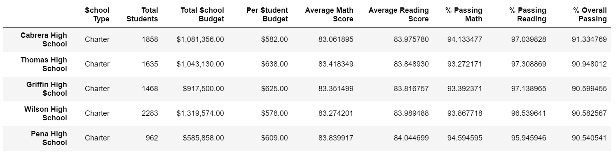

Original Data

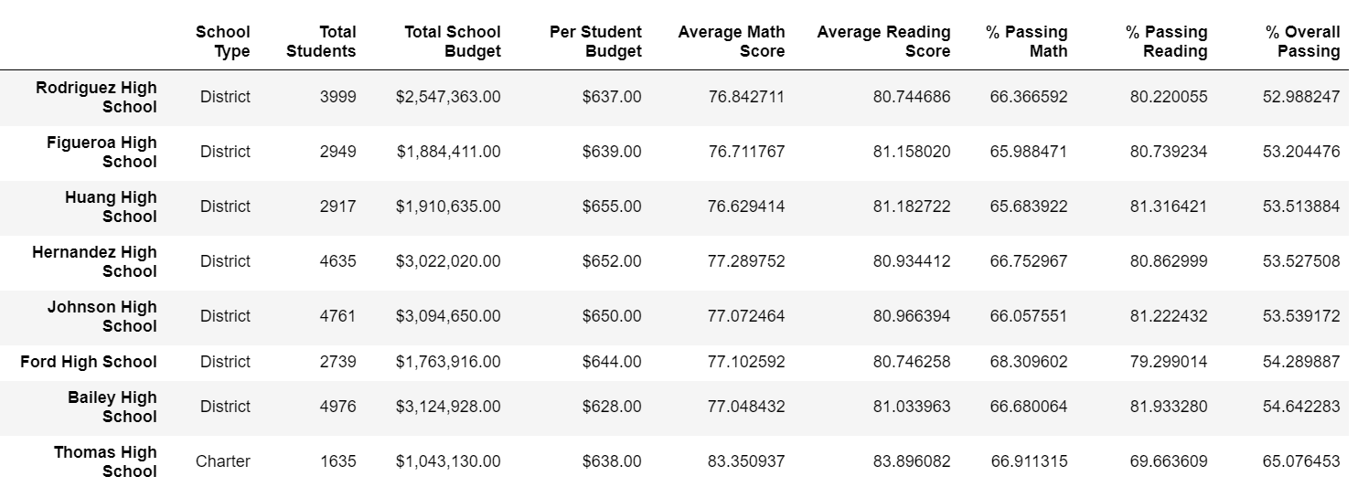

Thomas HS

**Effects on math and reading scores by grade**

The figures below show the ninth grade scores at THS are displayed as NaN. There was not a great difference between the comparison criteria when analysing the math and reading scores by grade.

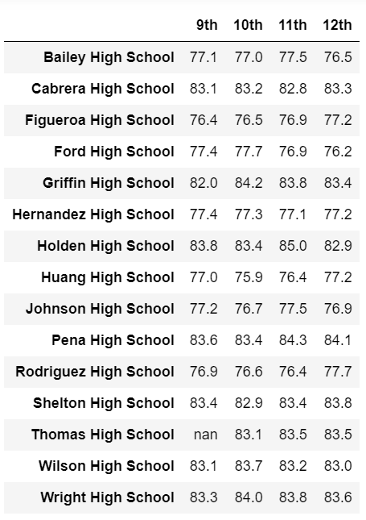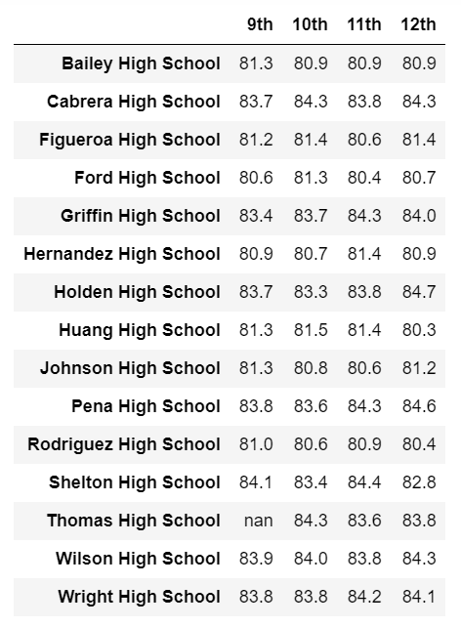

Original Data Thomas HS

**Effects on scores by school spending**

The spending range comparison (seen below), revealed that there was not a big differential between the average math and reading scores for the spending range of $630-644 per student spending.

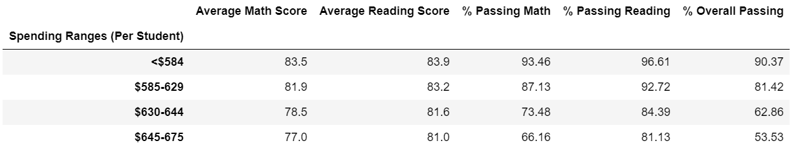

Original Data

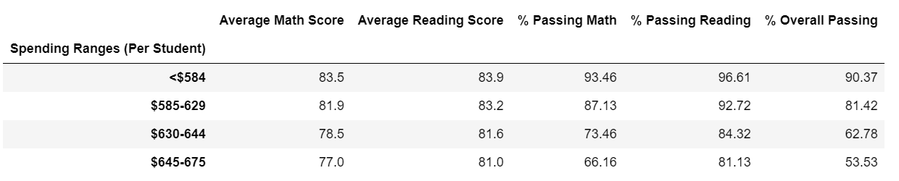

Thomas HS

**Effects on scores by school size**

In the figures below, the school size was compared and it showed that the average math and reading scores did not change much, once the THS ninth grade scores were removed. Medium sized schools fared better than the small or large schools.

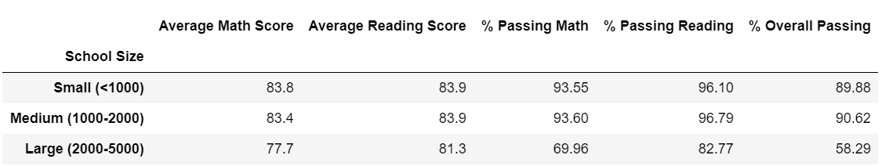

Original Data

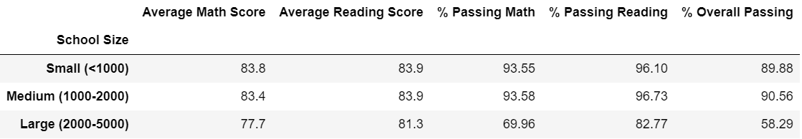

Thomas HS

**Effects on scores by school type**

In terms of school type there was nominal change in scores by school type; however, Charter schools performance was far better than the district schools over all (as seen below):

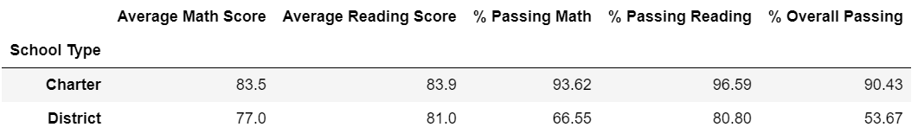

Original Data

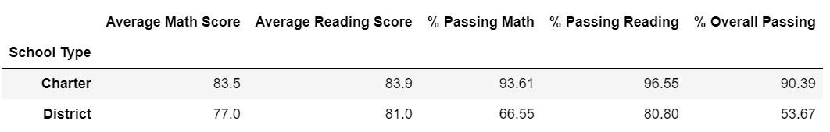

Thomas HS

**SUMMARY:**

The following four changes were observed in the updated school analysis after reading/math scores for 9th graders at THS were replaced with NaN’s

1. Test scores did not change significantly when removing the THS ninth graders test scores
2. THS demonstrated a significant decline in math, reading and overall passing rates when with 9th grade NaN implementation (91-65%)
3. THS’s rank decreased from 2nd to 8th out of 15 district HS
4. Charter school passing percentages declines; however, remained higher than district overall.

**REFERENCES:**

BCS

Google

GitHub

StackOverflow